Report on Industrial Visit To
Mettur Hydro Power Plant, Mettur.
(31.01.2020)

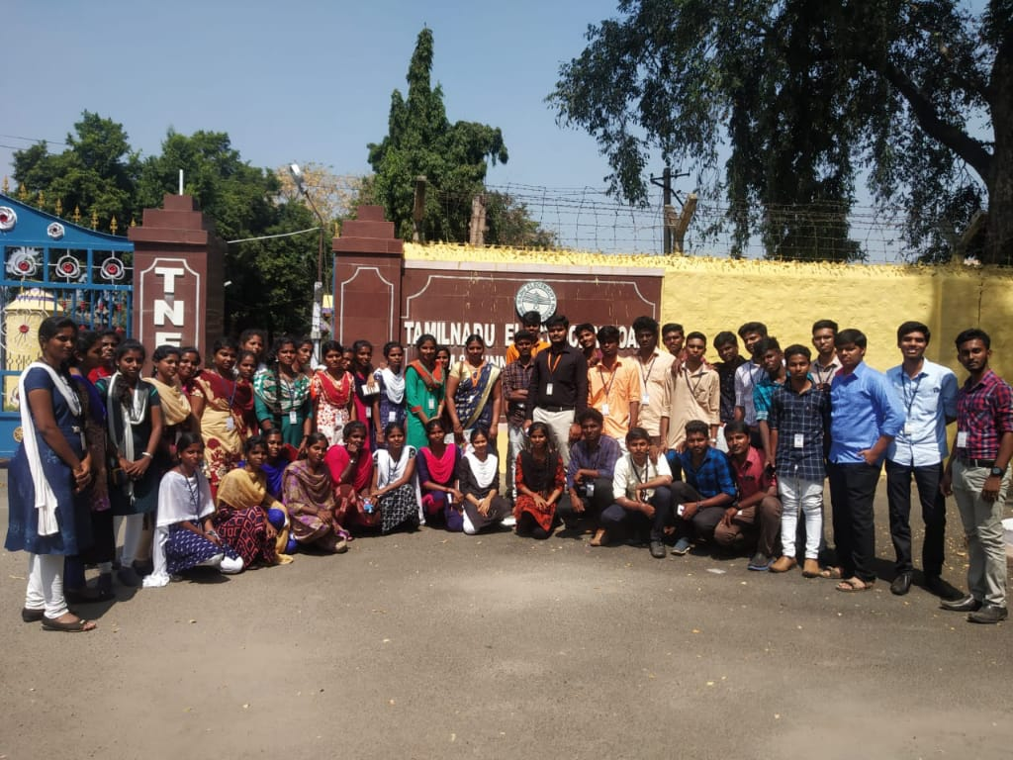

Department of EEE
Adhi College of Engineering and Technology
No.6, Munu Adhi Nagar, Sankarapuram, Walajabad,
Kanchipuram- 631605.

Total Number of student visited: 51
Organized by: JASMINE SUSILA.D, AP/EEE

INTRODUCTION TO THE COMPANY:
Mettur Hydroelectric Power Plant is located at Mettur, Near Salem, Tamil Nadu, India. Location coordinates are: Latitude = 11.7973° N, Longitude = 77.8106° E. This infrastructure is Hydro Power Plant type with a design capacity of 240 MW. It has 4 unit. The power project is commissioned in 1934. It is operated by Tamil Nadu Generation and Distribution Corporation Limited (TANGEDCO).

OVERVIEW OF THE PLANT:
Hydropower plants capture the energy of falling water to generate electricity. A turbine converts the kinetic energy of falling water into mechanical energy. Then a generator converts the mechanical energy from the turbine into electrical energy.

Parts of a Hydroelectric Plant
Most conventional hydroelectric plants include four major components (see graphic below):

Dam:
Raises the water level of the river to create falling water. Also controls the flow of water. The reservoir that is formed is, in effect, stored energy.

Turbine:
The force of falling water pushing against the turbine's blades causes the turbine to spin. A water turbine is much like a windmill, except the energy is provided by falling water instead of wind. The turbine converts the kinetic energy of falling water into mechanical energy.
Generator:
Connected to the turbine by shafts and possibly gears so when the turbine spins it causes the generator to spin also. Converts the mechanical energy from the turbine into electric energy. Generators in hydropower plants work just like the generators in other types of power plants.
Transmission lines:
Conduct electricity from the generating station to distribution side (consumers).
PLANT FEATURES:
Plant Capacity | : 240 MW
Land for Plant | : 42.5 square km.
Type of plant | : Vertical Kaplan
Length of penstock | : 0.63km.
Penstock (Internal diameter) | : 21 feet 6 inches to 19 feet 6 inches.
Height & Width of dam | : 214 & 171 feet

MAJOR COMPONENTS SPECIFICATIONS:
TURBINE:
The Kaplan turbine is an inward flow reaction turbine, which means that the working fluid changes pressure as it moves through the turbine and gives up its energy. Power is recovered from both the hydrostatic head and from the kinetic energy of the flowing water. The design combines features of radial and axial turbines.
The inlet is a scroll-shaped tube that wraps around the turbine's wicket gate. Water is directed tangentially through the wicket gate and spirals on to a propeller shaped runner, causing it to spin. The outlet is a specially shaped draft tube that helps decelerate the water and recover kinetic energy. The turbine does not need to be at the lowest point of water flow as long as the draft tube remains full of water. A higher turbine location, however, increases the suction that is imparted on the turbine blades by the draft tube. The resulting pressure drop may lead to cavitation.
Variable geometry of the wicket gate and turbine blades allow efficient operation for a range of flow conditions. Kaplan turbine efficiencies are typically over 90%, but may be lower in very low head applications.

GENERATOR:
In electricity generation, a generator is a device that converts motive power into electrical power for use in an external circuit. It works based on principle of faraday law of electromagnetic induction. The faradays law states that whenever a conductor is placed in a varying magnetic field, EMF is induced and this induced EMF is equal to the rate of change of flux linkages. This EMF can be generated when there is either relative space or relative time variation between the conductor and magnetic field. So the important elements of a generator are:
Generators are basically coils of electric conductors, normally copper wire, that are tightly wound onto a metal core and are mounted to turn around inside an exhibit of large magnets The specification of generator in the plant:
TRANSFORMER:
A transformer is an electrical device that transfers electrical energy between two or more circuits through electromagnetic induction. A varying current in one coil of the transformer produces a varying magnetic field, which in turn induces a voltage in a second coil. Power can be transferred between the two coils through the magnetic field, without a metallic connection between the two circuits. The specification of the transformer in power plant:

CIRCUIT BRAKEER:
A circuit breaker is an automatically operated electrical switch designed to protect an electrical circuit from damage caused by excess current, typically resulting from an overload or short circuit. Its basic function is to interrupt current flow after a fault is detected. Unlike a fuse, which operates once and then must be replaced, a circuit breaker can be reset (either manually or automatically) to resume normal operation.

CONCLUSION:
The Industrial Visit to the Mettur Hydro Power Plant, Mettur was highly successful. We received insight of the whole plant right from the raw material (water) procurement, processing, generation & transmission of electricity. The whole process was explained in detail by their representative with detailed description about each equipment with their specifications. A doubt solving session with the Control Room Incharge cleared all our queries. This kind of industrial exposure helped us to absorb the theoretical aspects of Power Plant and Power Electronics Engineering more efficiently.

